Functional Specification for Air Quality Review System (AQR)
- System Introduction
The Air Quality Review (AQR) System is a standalone software application designed to automate the analysis of environmental data (Temperature, Humidity, and Pressure) from CSV source files. The system ensures high data accuracy in compliance with GxP standards and ALCOA+ principles. It provides a seamless integration between a user-friendly web interface and a robust calculation engine.
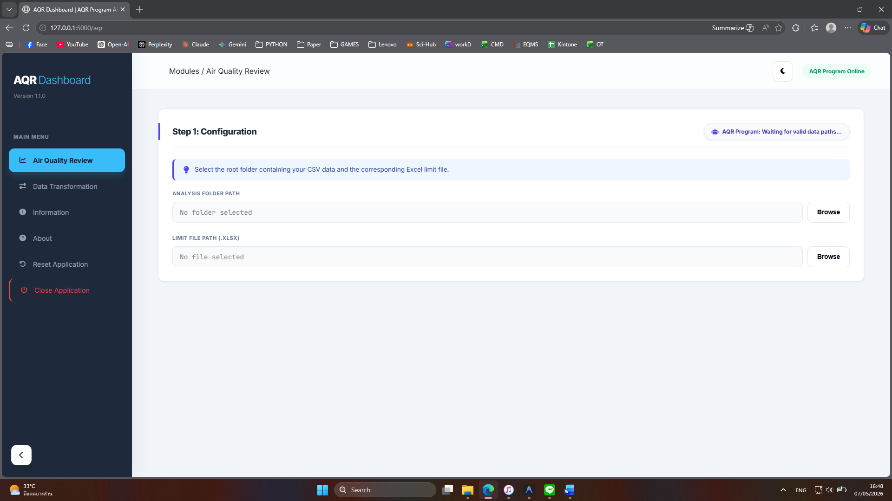
- Core Functional Modules
- Module 1: Data Input & Header Parsing
- Function: Identifies the starting point of data within complex CSV files.
- Logic: The system utilizes a find_header() function to scan for the <>Date keyword. This allows the program to skip irrelevant metadata and automatically map the required data columns for analysis.
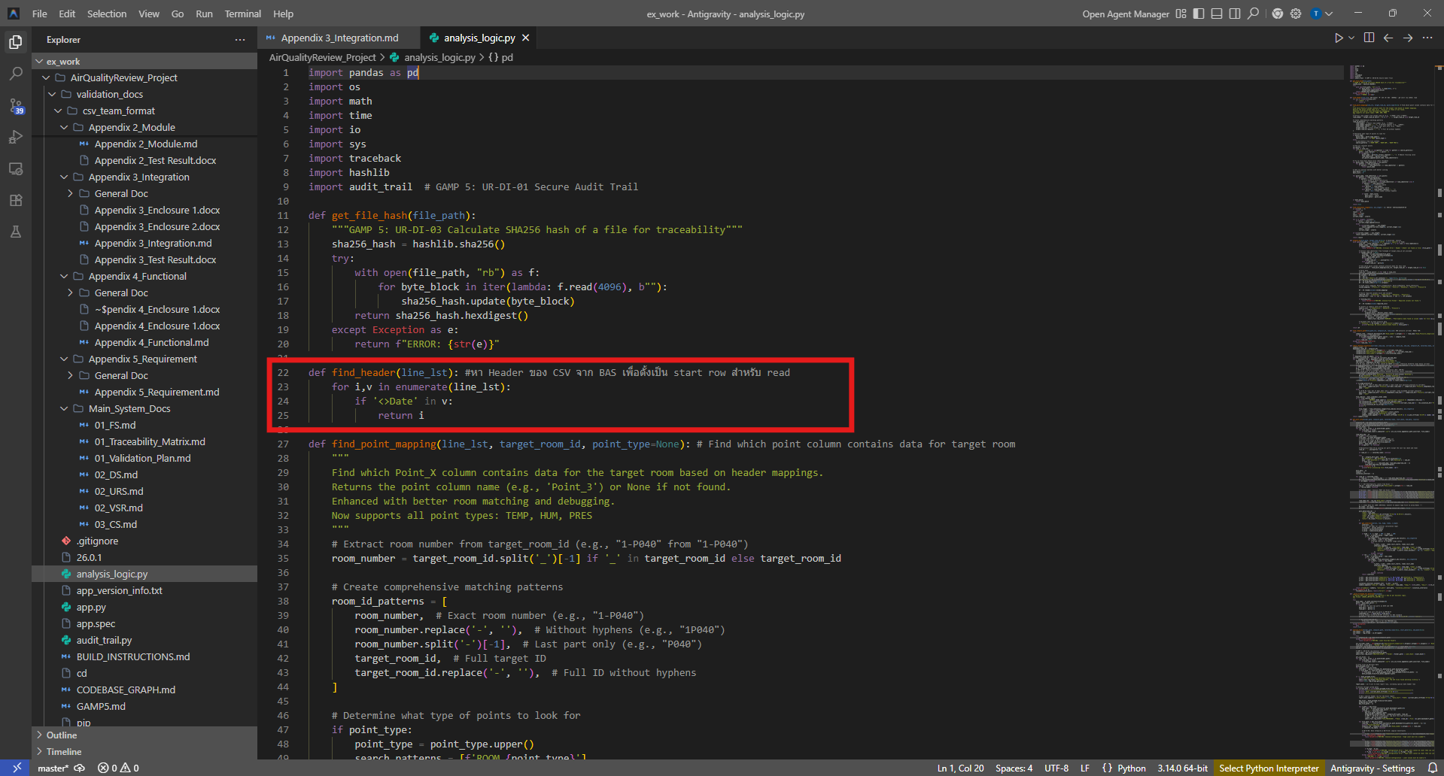
- Module 2: Environmental Rule Processing (25-Minute Rule)
- Function: Validates the continuity of temperature or humidity excursions.
- Logic: Based on a 5-minute sampling rate, the system requires 6 consecutive data points to confirm a violation. It calculates the time difference between the current record and the record 5 rows prior. If the difference is exactly 1,500 seconds (25 minutes), the event is flagged as a "Strict Continuity Violation."
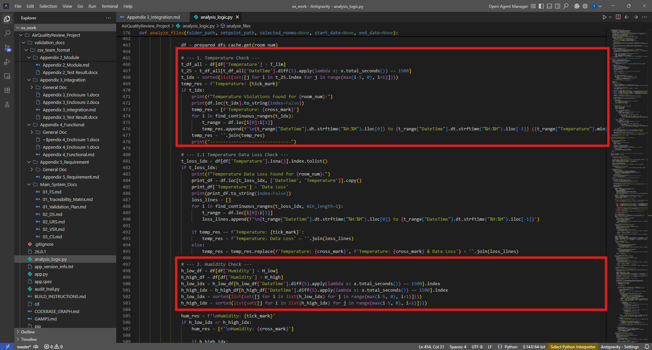
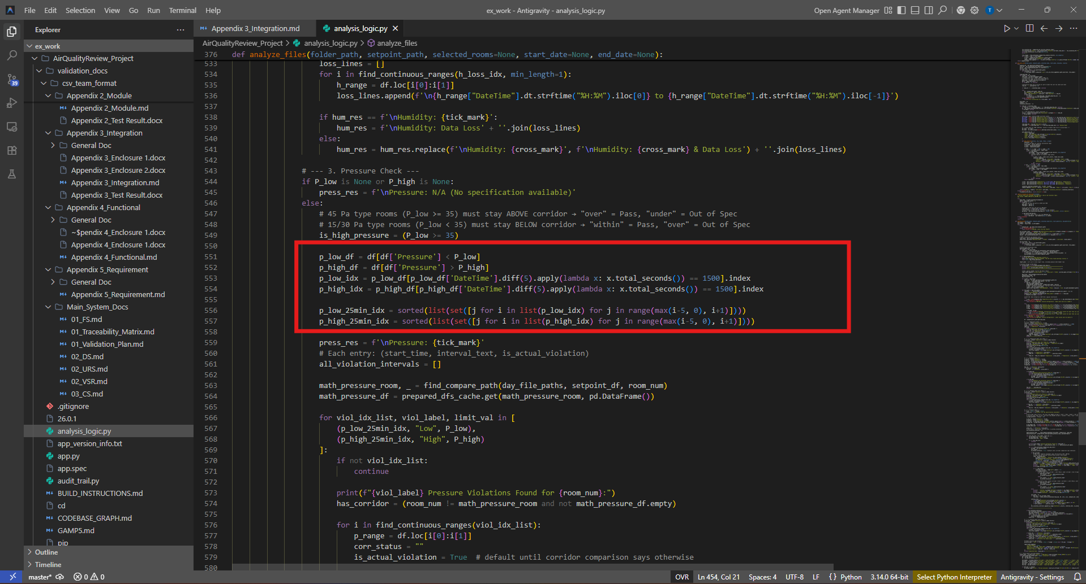
- Module 3: 10-Minute Gap Threshold
- Function: Manages missing data points (Data Gaps) to prevent inaccurate reporting.
- Logic: If the time gap between two consecutive records exceeds 600 seconds (10 minutes) using differential 5 row as indicator if 5 row different is more than 1500 second, the system immediately resets the duration counter. This prevents the software from "connecting" disconnected events, ensuring the integrity of the duration calculation, as shown in 2 figures above.
- Module 4: Differential Pressure Logic
- Function: Compares pressure levels between cleanrooms and corridors.
- Logic: The system performs an Inner Join operation to synchronize data from two different files based on an exact timestamp. This ensures that the pressure difference (Delta P) is calculated using records captured at the same moment.
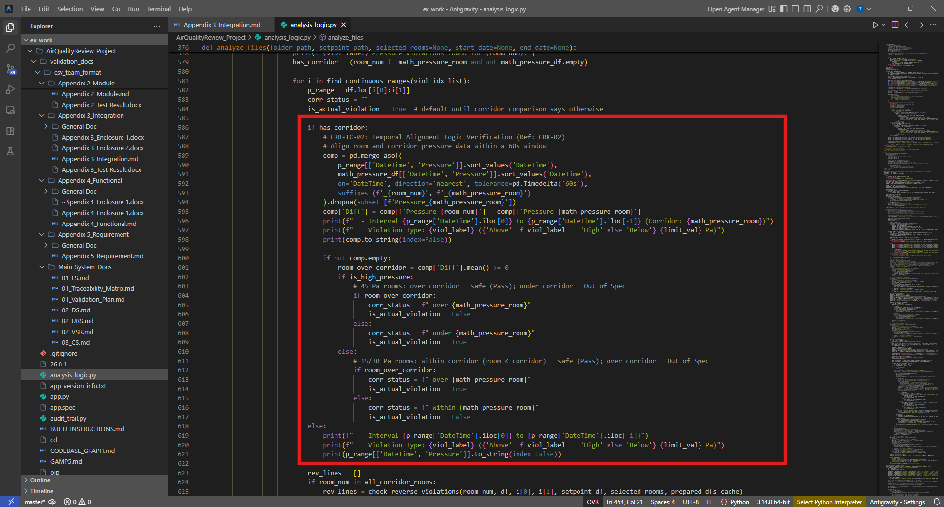
- Data Integrity & Security Features
- Secure Audit Trail: Every user activity is logged in a JSON Lines format with SHA-256 Hash-chaining. Each log entry is mathematically linked to the previous one. If the file is manually edited (e.g., via Notepad), the system detects the "broken chain" and prevents further operation to protect the audit history.
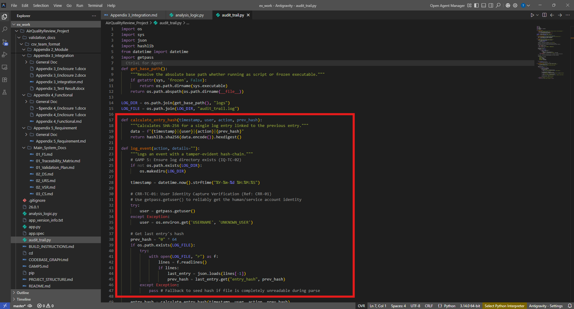
- Read-Only Data Access: The software is strictly programmed to access source data in "Read-Only" mode. It is technically impossible for the system to modify or delete the original raw records.
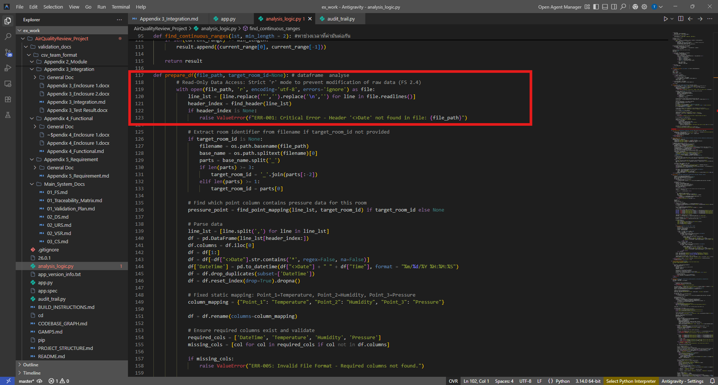
- Digital Fingerprinting (Checksums): The system generates unique SHA-256 checksums for every data file and the SetPointLimit.xlsx file before analysis. This confirms that no unauthorized changes have been made to the input data.
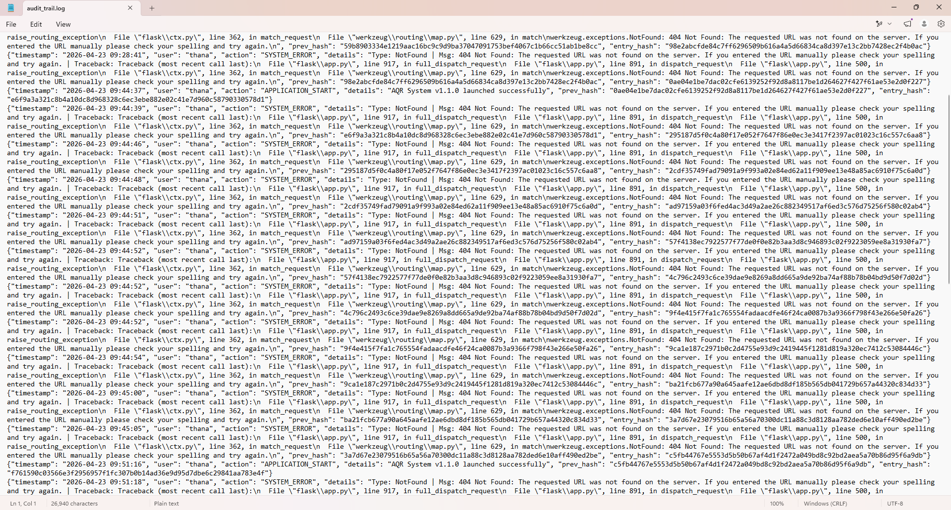

- User Interface & Reporting
- Directory Verification: The system verifies the existence and accessibility of the selected folder before starting the analysis process.
- Reporting Engine: Upon completion, the system generates a standardized Excel report containing a detailed list of all verified violations.
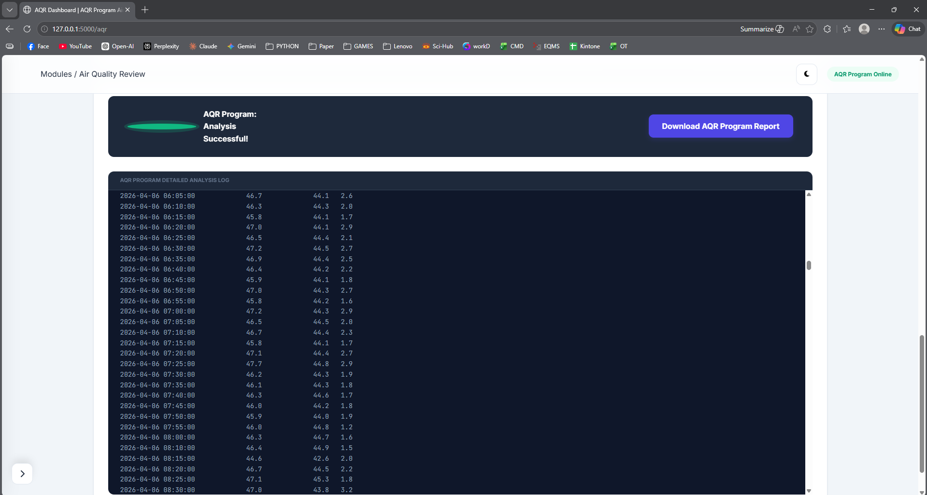
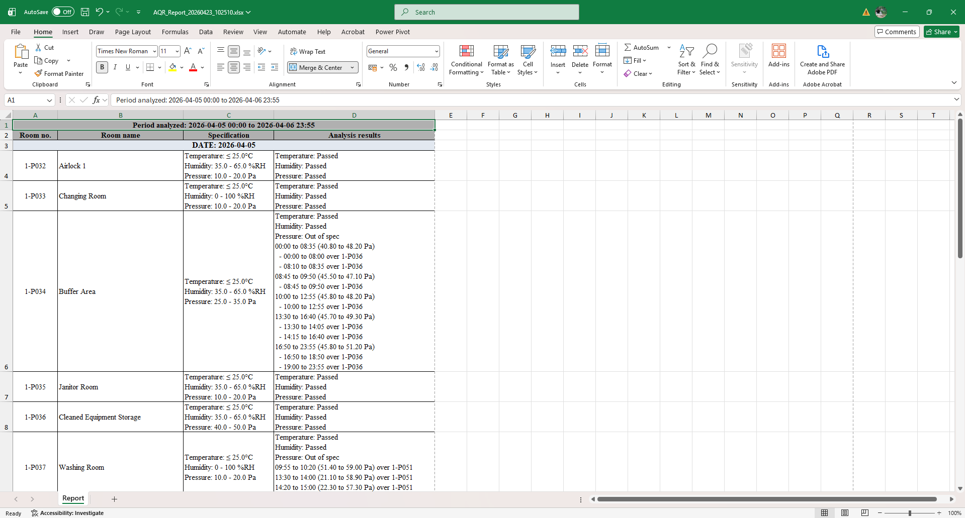

- Error Handling Catalog
Error Code | Category | Technical Description | User Interface Message
ERR-001 | Data Format | The system failed to locate the mandatory <>Date keyword required to start the analysis. | "Critical Error: Invalid CSV Format. Header missing."
ERR-002 | Infrastructure | The required configuration file (SetPointLimit.xlsx) is missing from the root directory. | "System Error: SetPointLimit.xlsx not found."
ERR-003 | Configuration | One or more limit values in the Excel file are non-numeric or missing. | "Invalid Configuration: Limit values must be numeric."
ERR-004 | Security | The cryptographic hash-chain in the audit log is broken, indicating unauthorized tampering. | "Security Alert: Audit Trail integrity check failed."
ERR-005 | Data Integrity | One or more mandatory columns (Temperature, Humidity, or Pressure) are missing from the source CSV. | "Invalid File Format: Required data columns not found."
ERR-006 | Logic Validation | The defined High Limit is lower than the Low Limit in the configuration file. | "Configuration Error: High Limit cannot be lower than Low Limit."
ERR-999 | System | General unhandled exception (details are automatically logged in the audit trail). | "Internal Server Error. Please check the audit log."

